/ behtare az function component bishtar estefade koni , va class componento vaghti state dari ke yani chizi ke to safe valuesh avaz mishe mesle vaghti ro button clik mikoni <div valuesh avaz mishe on moghe on chiz ke dar dive bezar dar state class component (to ask 7 here ) masalan

/ this.props.nameproperty o vaghti minevisi ke dakhele **class component** bashe

& age **function component** bood on moghe nemikhad this. Benevisi kafeie faghat props.nameproperty

/ props vaghti ke dar ye component ya function component property ezafe mikoni hamon reference ke midi dar ghesmate render akhar va bad mikhay on propertyio dar khode component estefade koni bad migi props *properties(

Mesal property ke sakhti dar zir < result >

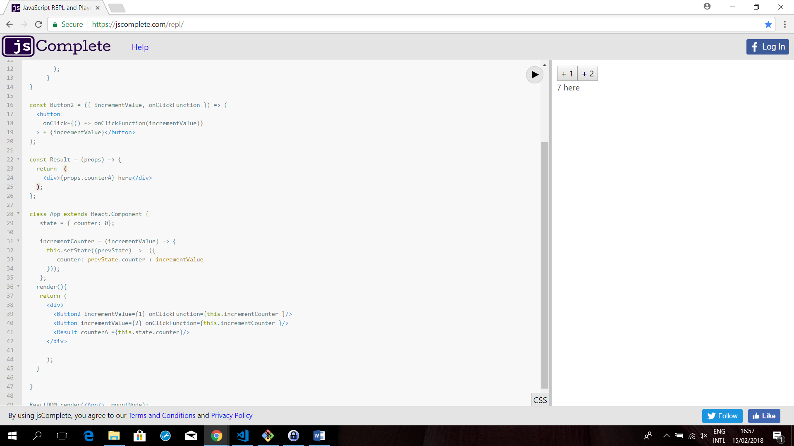

Va button version1 nemone props

